**FACIAL CLEANSER/WASH**

*SKIN TYPE: NORMAL*

(PRICES 100 - 500)

1. **Cetaphil Gentle Skin Cleanser (60ml)**

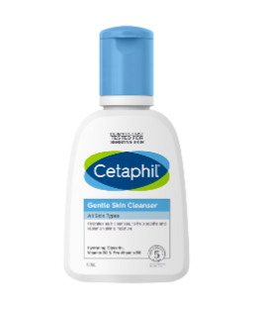

**WHAT IT DOES:** This gentle cleansing formula, now with hydrating Glycerin, Vitamin B3 & Pro-Vitamin B5, is clinically tested to be gentle at removing dirt, makeup and impurities, while preserving skin's natural moisture barrier. It's fragrance free, paraben free, non-comedogenic, and hypoallergenic.

**HOW TO USE:** With water: Apply cleanser and gentle massage into skin. Rinse, if without water: Apply a liberal amount of cleanser and gently massage into skin.

**PRICE:** ₱ 172.00

**BENEFICIAL INGREDIENTS**: 5/10 ingr.

**DEBATABLE INGREDIENTS**: 4/10 ingr.

1. **Cosrx Low Ph Good Morning Gel Cleanser (50ml)**

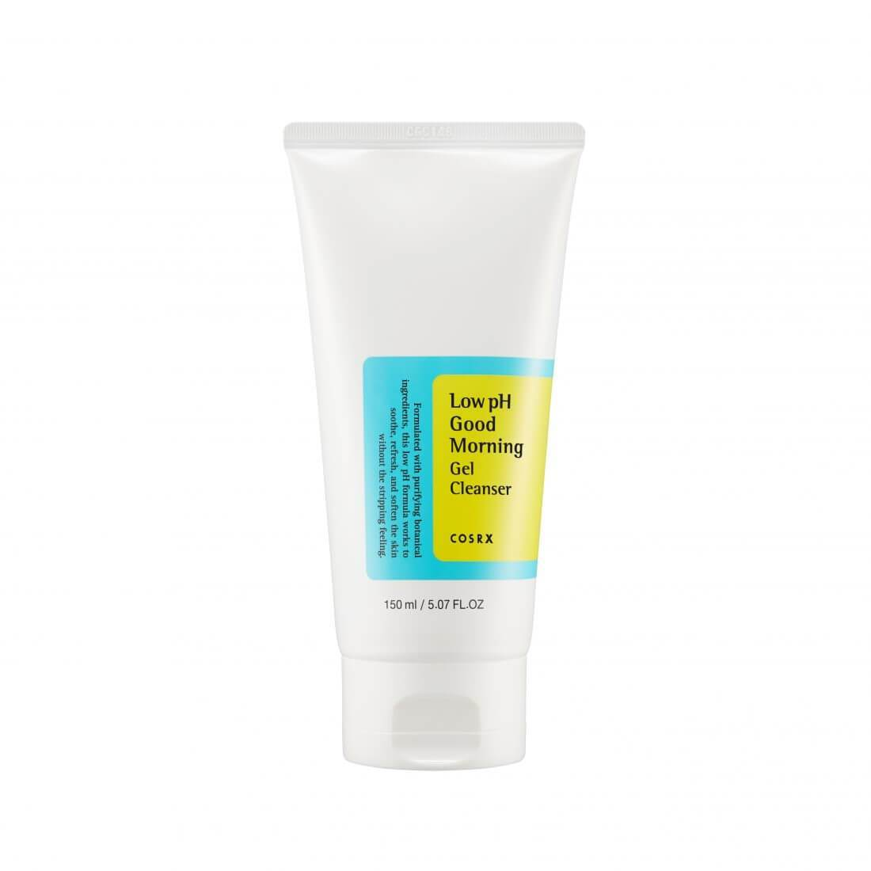

**WHAT IT DOES:** Gentle gel type cleanser with mildly acidic pH level. While refining the skin texture, the cleanser will help cleanse with no stripping. Great for all skin types, wake up to a firmer-looking skin while letting it rest clean during the night.

**HOW TO USE:** Use morning and night, after removing makeup. Begin with wet hands and face. Squeeze a proper amount onto your hand and foam up. Gently massage onto face avoiding the eye and mouth area. Rinse with warm water.

**PRICE:** ₱ 299.00

**BENEFICIAL INGREDIENTS**: 5/18 ingr.

**DEBATABLE INGREDIENTS**: 1/18 ingr.

1. **OXECURE pH 5.5 Gentle Cleanser (200ml)**

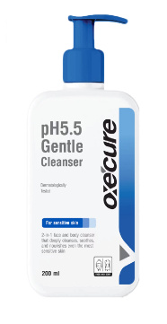

**WHAT IT DOES:** An ultra mild, non-irritating, pH5.5 face and body cleanser that maintains your skin?s natural pH balance as it gently washes away dirt, germs, and other skin impurities. Hypoallergenic and fragrance-free, it?s formulated with Dual Moisture Lock Technology to hydrate your skin barrier and soothe skin while cleansing. Also contains Encapsulated Salicylic Acid to gently exfoliate dead skin and Mangosteen Extract to help reduce the accumulation of bacteria while soothing skin that?s prone to itchiness, irritation, flaking, and redness.

**HOW TO USE:** Lather a small amount on your palm and apply on wet skin. Then, rinse off with water. Can be used on the face and body, morning and night

**PRICE:** ₱ 379.00

**BENEFICIAL INGREDIENTS**: 5/18 ingr.

**DEBATABLE INGREDIENTS**: 1/18 ingr.

PRICES (500-1000)

1. **The Ordinary Squalane Cleanser (50 ml)**

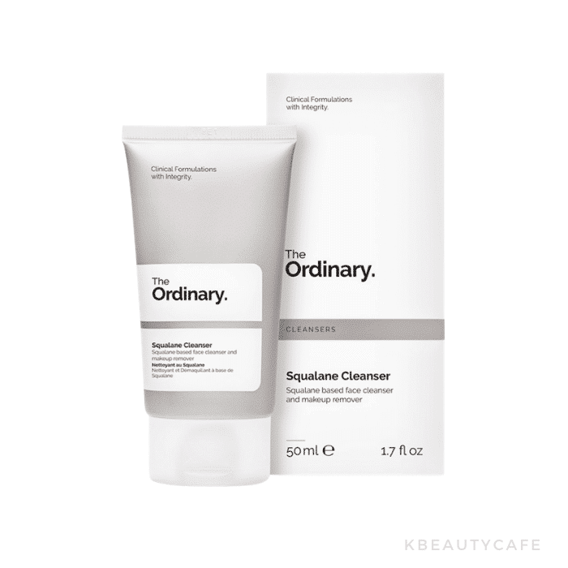

**WHAT IT DOES:** A gentle cleansing product formulated to remove sunscreen and makeup. The Ordinary Squalane Cleanser features squalane and other lipophilic esters that are gentle and moisturizing. Housed in a convenient tube packaging, this balm-type cleanser melts into an oil when massaged unto skin.

**HOW TO USE:** Dispense product onto hands. Rub together to melt balm into oil. Massage onto dry face and rinse off with lukewarm water. Follow with the rest of your routine

**PRICE:** ₱ 575.00

**BENEFICIAL INGREDIENTS**: 5/18 ingr.

**DEBATABLE INGREDIENTS**: 1/18 ingr.

1. **Neutrogena Hydro Boost Gentle Facial Cleanser (145 ml)**

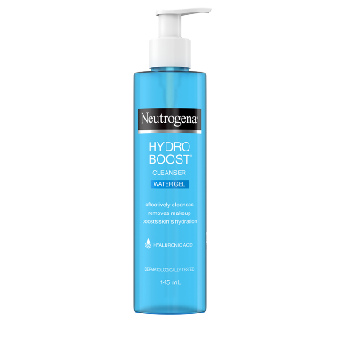

**WHAT IT DOES:** NEUTROGENA®, Hydro Boost Cleanser Water Gel is a lightweight gel cleanser with BARRIERCARE technology transforms into a silky lather to effectively lift away dirt, oil, and makeup without disrupting the skin barrier. With Hyaluronic Acid, the formula is clinically proven to boost skin's hydration levels and help lock it in, leaving skin refreshingly clean and hydrated, every time you cleanse.

**HOW TO USE:** Wet face. Apply to hands, add water and work into a lather. Massage face gently. Rinse thoroughly.

**PRICE:** ₱ 530.00

**BENEFICIAL INGREDIENTS**: 4/14 ingr.

**DEBATABLE INGREDIENTS**: 2/14 ingr.

1. **La Roche-Posay Toleriane Hydrating Gentle Cleanser (400 ml)**

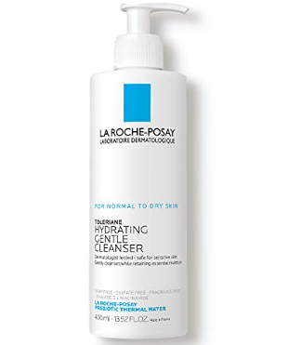

**WHAT IT DOES:** Toleriane Hydrating Gentle Cleanser is a daily face wash for normal to dry, sensitive skin. Formulated with La Roche-Posay prebiotic thermal spring water, niacinamide, and ceramide-3, this face wash gently cleanses skin of dirt, makeup, and impurities while maintaining skin's natural moisture barrier and pH. Its gentle cream formula helps restore skin comfort and retains essential moisture, leaving the skin feeling comfortable and hydrated.

**HOW TO USE:**  Use luke-warm water to wet face and apply in ciruclar motions then rinse with water and tap skin dry to avoid friction.

**PRICE:** ₱ 530.00

**BENEFICIAL INGREDIENTS**: 4/14 ingr.

**DEBATABLE INGREDIENTS**: 2/14 ingr.

PRICES (1000-above)

1. **Vanicream Gentle Milk Facial Cleanser (237 ml)**
2. **AVENE Gentle Milk Cleanser (200ml)**
3. **Glymed Gentle Facial Cleanser (236 ml)**